Perran-ar-worthal

Local History Group

**Tuesday 22nd Nov**

**7.30pm at The Perranwell Centre**

**A talk by well known speaker Kingsley Rickard entitled:**

**‘Quirky Cornwall’**

Kingsley has been on the look out for different and unusual scenes and buildings, including old granite milestones, Cornish Crosses and all sorts of landscapes, sites and structures.

Come along and learn about their history and find a few new places to explore yourselves.

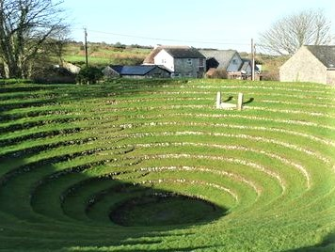 Gwennap Pit